** ComputerNetworks**

Assignment 1 (Phase-1)

**Group Members:**

**Umair Ahmed**

**Muhammad Ali Qasim**

**Hamza Rehmat  
Sohaib Ahmed**

**Submitted to:**

**Asst. Prof Bilal Rauf**

**BESE-23(B)**

**DEPARTMENT OF COMPUTER SOFTWARE ENGINEERING**

**Military College of Signals**

**National University of Sciences and Technology**

[**www.mcs.nust.edu.pk**](http://www.mcs.nust.edu.pk)

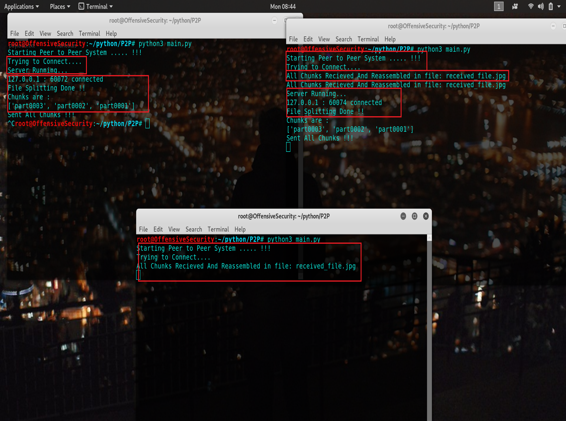

2nd peer received chunks, reassembled in a file

Peer become Server And it 2nd peer connected to it

Peer Received 250 kb chunks & assembled file

Peer Up/Connected to Server

Server Up/Peer Connected

File Spitted into 250 kb chunks and Sent



**Fig 1** Size of both files are equal.

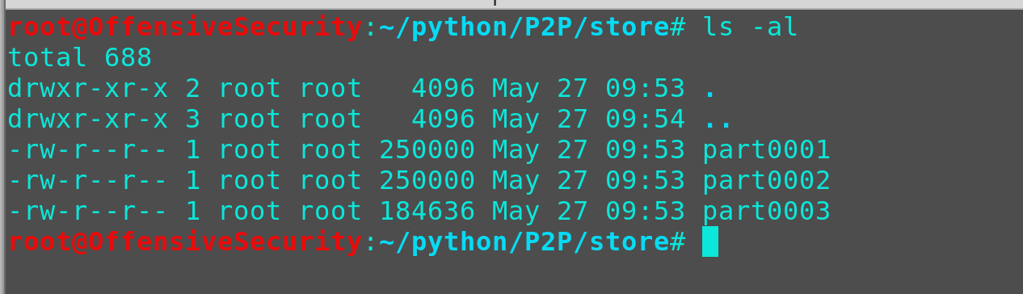

**Fig 2** List of files displayed.

**Main.py code description**

**Server.py code description and main functions called in it**

**Client.py code detail description**

**Handler.py function detailed description**

**Sendfile.py function detailed description**

**Split.py function detailed description**